FPGA Hardware Interface Structure
WiMAX IEEE 802.16-2007 PHY Layer Transmitter
Target Board: DE0-CV 5CEBA4F23C7 (Cyclone V FPGA)


Contents
Buttons (Active-Low) 3
KEY0 — Reset 3
KEY1 — Load/Start 3
Switch 3
SW0 — Mode Select 3
LED Indicators 3
Pass/Fail Status LEDs (LEDR[3:0]) 3
Verification Complete LEDs (LEDR[7:4]) 4
System Status LEDs (LEDR[9:8]) 4
Verification Method 4
Operation Summary 4
Expected Successful Operation 4
Pin Assignment Summary 5
Credits 5

Buttons (Active-Low)

KEY0 — Reset
- Function: System reset
- Behavior: Press to reset the entire system. Clears all verification states, counters, and latched status registers. Prepares for a new verification cycle.
- Pin Assignment: PIN_U7

KEY1 — Load/Start
- Function: Initialize PRBS and start transmission
- Behavior: Press to load the PRBS seed and begin processing data through the WiMAX PHY pipeline. Triggers verification of 5 consecutive packets against golden reference data.
- Pin Assignment: PIN_W9
- Note: Button is debounced (~10ms) to prevent multiple triggers.

Switch

SW0 — Mode Select
- Pin Assignment: PIN_U13
- LOW (0): Single-shot mode — Processes and verifies 5 packets, then automatically stops. Enable signal (LEDR[8]) turns off after verification completes.
- HIGH (1): Continuous mode — Continuously processes packets indefinitely. Useful for long-term stability testing.

LED Indicators
The DE0-CV board provides 10 LEDs (LEDR[9:0]) for status indication. All LEDs are active-HIGH (ON = logic 1).

Pass/Fail Status LEDs (LEDR[3:0])
These LEDs indicate whether each processing stage passed verification across ALL 5 packets. They start ON (assuming pass) and latch OFF if ANY packet fails.
LED | Signal | Description
LEDR[0] | PRBS Pass | ON: All 5 packets from randomizer match golden data OFF: At least one packet failed verification
LEDR[1] | FEC Pass | ON: All 5 packets from FEC encoder match golden data OFF: At least one packet failed verification
LEDR[2] | Interleaver Pass | ON: All 5 packets from interleaver match golden data OFF: At least one packet failed verification
LEDR[3] | Modulator Pass | ON: All 5 packets from QPSK modulator match golden data OFF: At least one packet failed verification

Verification Complete LEDs (LEDR[7:4])
These LEDs indicate when verification has completed for each processing stage (all 5 packets processed).

LED | Signal | Description
LEDR[4] | PRBS Verified | ON: All 5 PRBS/randomizer packets have been verified
LEDR[5] | FEC Verified | ON: All 5 FEC encoder packets have been verified
LEDR[6] | Interleaver Verified | ON: All 5 interleaver packets have been verified
LEDR[7] | Modulator Verified | ON: All 5 modulator packets have been verified

System Status LEDs (LEDR[9:8])
LED | Signal | Description
LEDR[8] | Enable Active | ON: System is actively processing data OFF: System idle or verification complete (single-shot mode)
LEDR[9] | PLL Locked | ON: PLL is locked, 50 MHz and 100 MHz clocks are stable OFF: PLL not yet locked, system not ready for operation

Verification Method
The system uses golden data comparison to verify correct operation of each processing stage:
- Golden reference data is defined in wimax_pkg.sv
- Each stage output is compared bit-by-bit against expected values
- Verification runs for 5 consecutive packets (configurable via NUM_PACKETS parameter)
- Pass LEDs remain ON only if ALL 5 packets pass for that stage
- QPSK modulator verification compares I/Q sign bits against expected constellation mapping

Operation Summary
- Press KEY0 to reset the system
  - LEDs 0-3 remain ON after pressing KEY0 (reset) because the design correctly resets the pass-latched signals to their initial PASS state (1'b1), as intended for "assume pass until proven otherwise" logic.
- Wait for LEDR[9] to turn ON (PLL locked)
- Set SW0 to desired mode (DOWN for single-shot, UP for continuous)
- Press KEY1 to load PRBS seed and start transmission
- Observe LEDR[8] turn ON (enable active)
- After verification completes (all 5 packets processed):
- LEDR[7:4] turn ON (verification complete for each stage)
- LEDR[3:0] indicate pass/fail status:
- All 4 LEDs ON = SUCCESS (all stages passed)
- Any LED OFF = FAILURE (that stage had at least one packet fail)
- LEDR[8] turns OFF in single-shot mode (enable deasserted)

Expected Successful Operation
When the design is functioning correctly, after pressing KEY1:
- LEDR[9] = ON (PLL locked)
- LEDR[8] = ON during processing, OFF after completion (single-shot)
- LEDR[7:4] = All ON (all stages verified)
- LEDR[3:0] = All ON (all stages passed)

Pin Assignment Summary
Signal | Pin | I/O Standard | Function
CLOCK_50 | PIN_M9 | 3.3-V LVTTL | 50 MHz Clock Input
KEY0 | PIN_U7 | 3.3-V LVTTL | Reset (Active-Low)
KEY1 | PIN_W9 | 3.3-V LVTTL | Load/Start (Active-Low)
SW0 | PIN_U13 | 3.3-V LVTTL | Mode Select
LEDR[0] | PIN_AA2 | 3.3-V LVTTL | PRBS Pass
LEDR[1] | PIN_AA1 | 3.3-V LVTTL | FEC Pass
LEDR[2] | PIN_W2 | 3.3-V LVTTL | Interleaver Pass
LEDR[3] | PIN_Y3 | 3.3-V LVTTL | Modulator Pass
LEDR[4] | PIN_N2 | 3.3-V LVTTL | PRBS Verified
LEDR[5] | PIN_N1 | 3.3-V LVTTL | FEC Verified
LEDR[6] | PIN_U2 | 3.3-V LVTTL | Interleaver Verified
LEDR[7] | PIN_U1 | 3.3-V LVTTL | Modulator Verified
LEDR[8] | PIN_L2 | 3.3-V LVTTL | Enable Active
LEDR[9] | PIN_L1 | 3.3-V LVTTL | PLL Locked

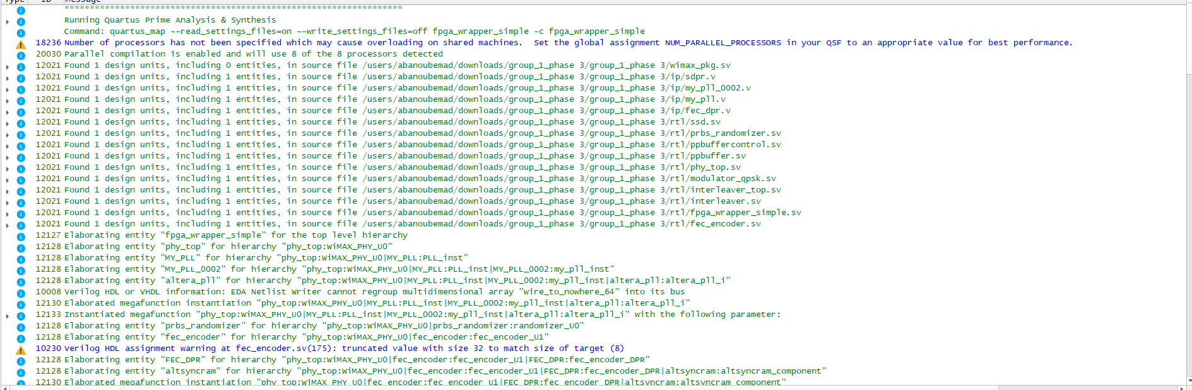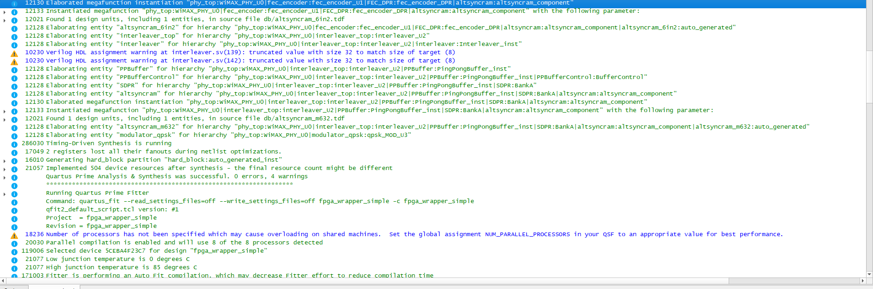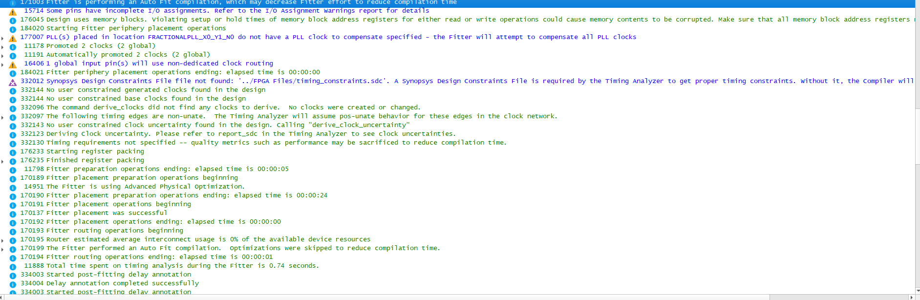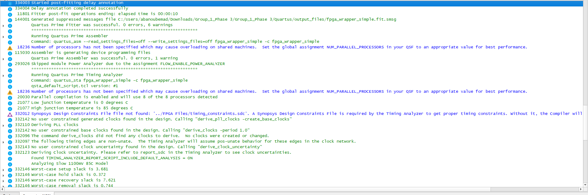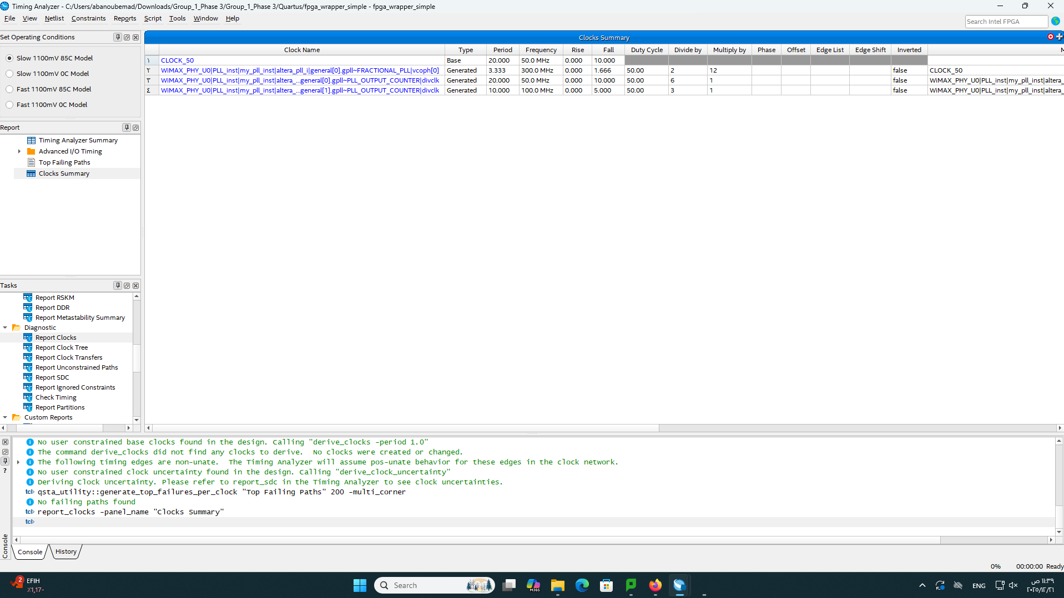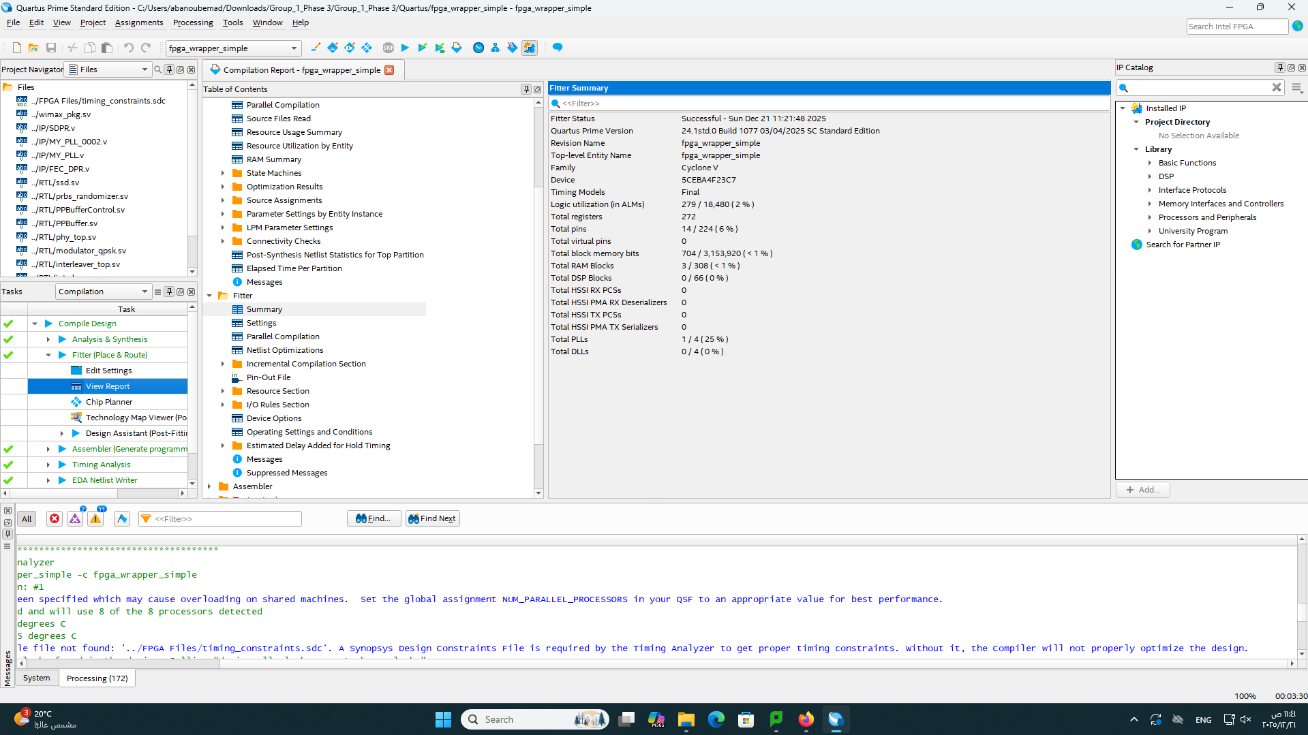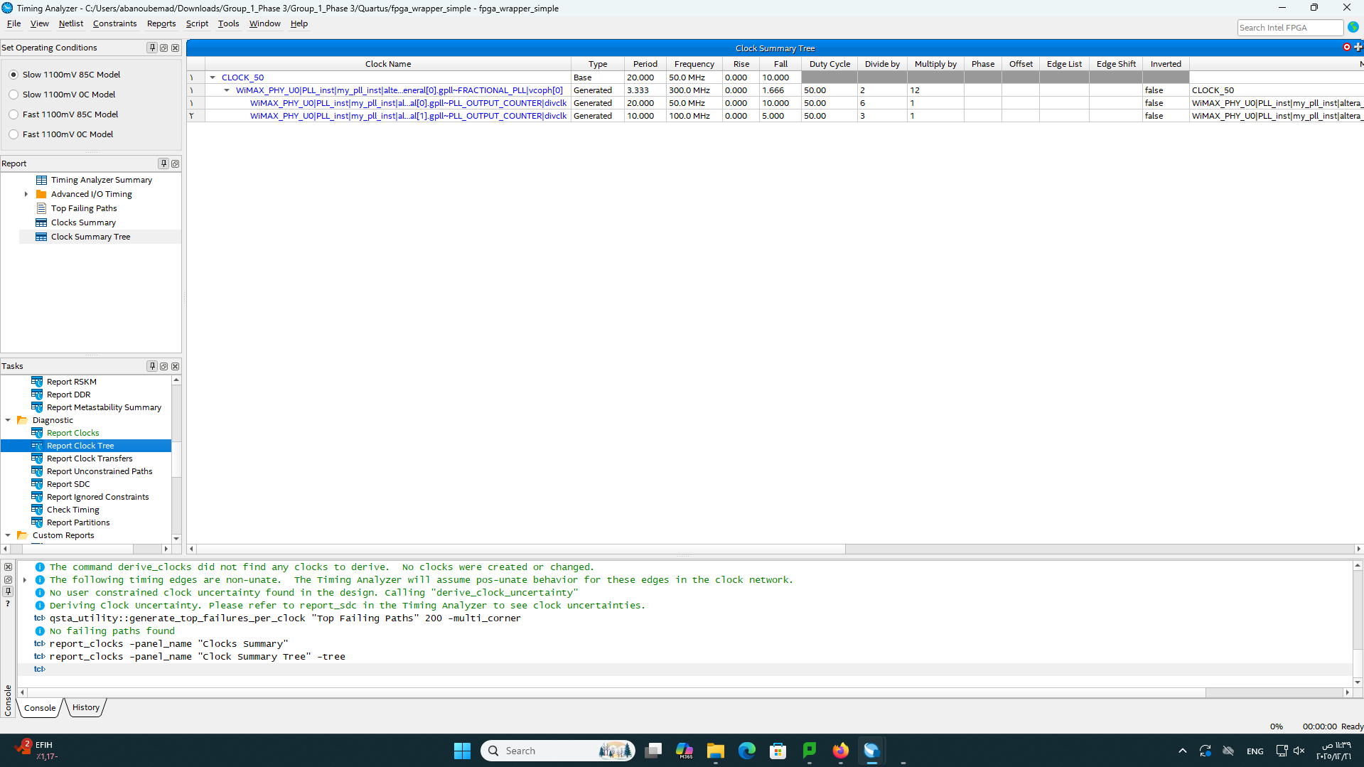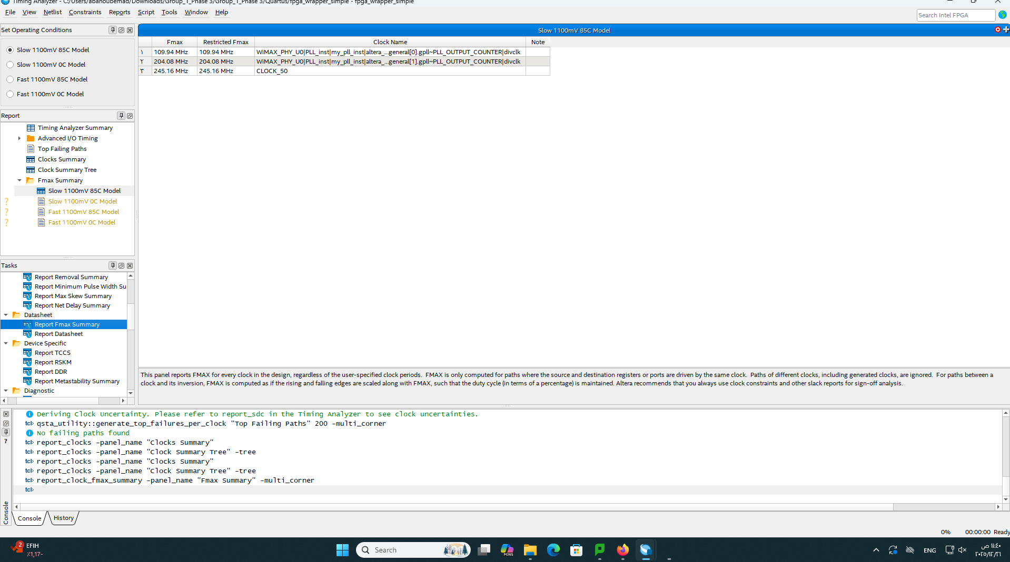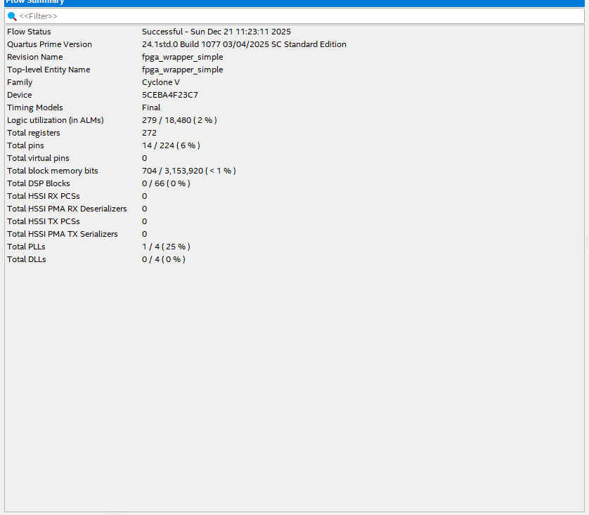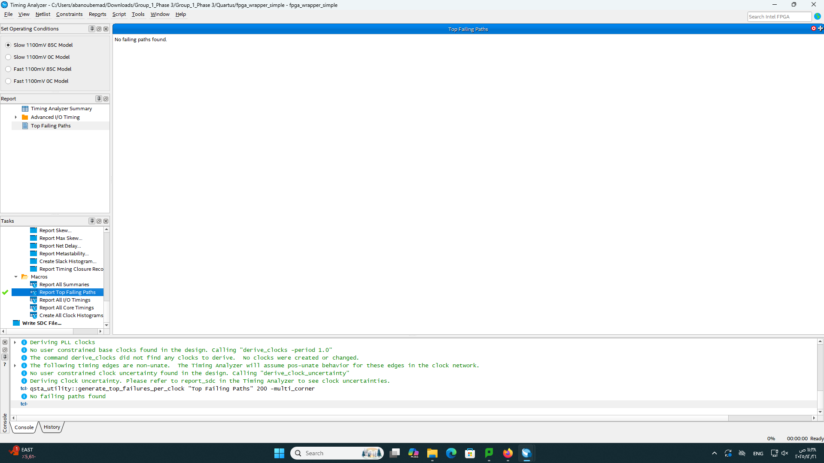

Credits
Made by Team 1:
- Abanoub Emad
- John Fahmy
- Omar ElShazli

Supervised by: Dr. Ahmed Abou Auf
Course: ECNG410401 ASIC Design Using CAD
Date: December 2025

